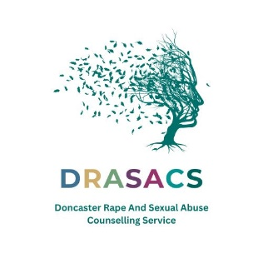
DRASACS Data Subject Access Request- Applicable to Adults
As part of DRASACS support we need to securely retain (store) information about service users and any interactions (meetings, phone calls, letters) which they have with DRASACS employees.
If you would like to receive a copy of the information stored by the organisation, please complete the form below and return with a £10 fee (cheque/PO) (please note if you are requesting a copy of counselling notes, no fee applies, and this can be done by contacting the organisation by telephone).
Please note records relating to counselling are deleted after six years and ISVA 40 years, unless the client was under 18 when they accessed DRASACS.

Name

Date of Birth

Address

Contact Number

Counselling ISVA Please tick (can be both)

Signature______________________
This form (with payment) needs to be sent to DRASACS CEO, Floor 2, 22-28 Wood street, Doncaster, South Yorkshire DN1 3LW

